Aquatic Mollusks Found in the Study Area.

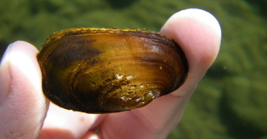 | 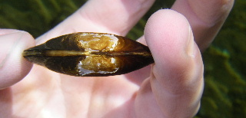
Margaritifera falcata

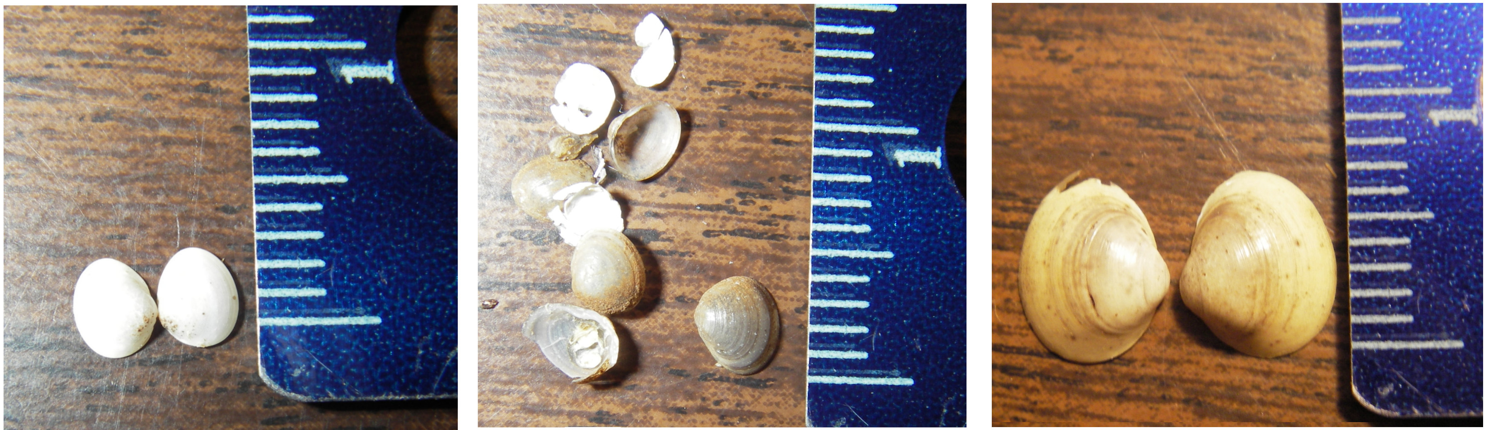
Pisidium casertanum | Pisidium walkeri | Pisidium species

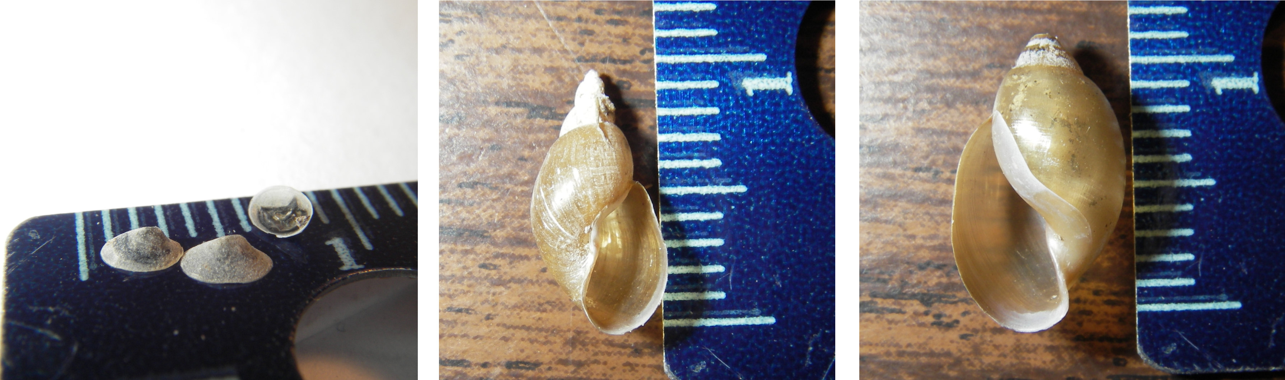
Ferrissia rivularis | Fossaria obrussa | Physella gyrina

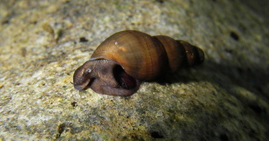 | 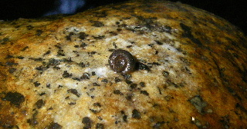
Juga nigrina | Menetus opercularis

Terrestrial Mollusks Found in the Study Area.

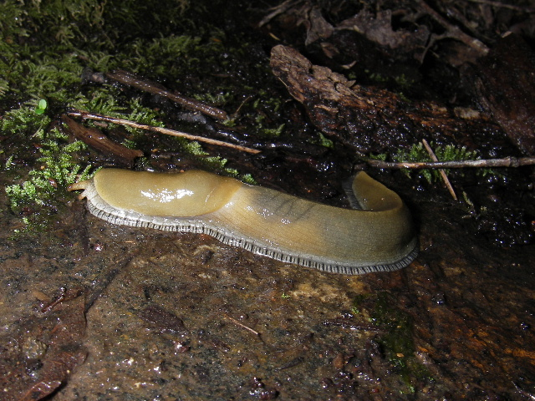 | 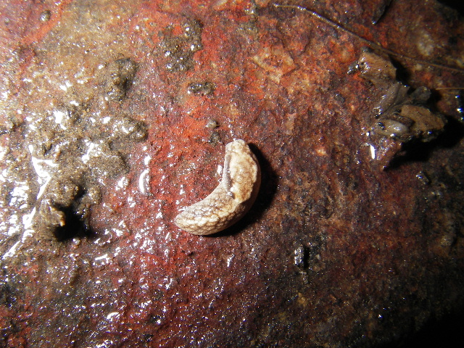
Ariolimax species | Prophysaon andersoni
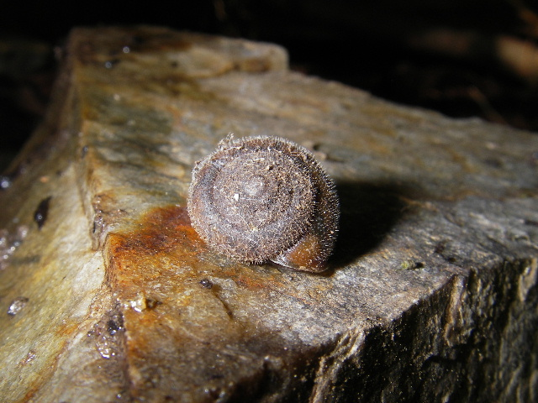 | 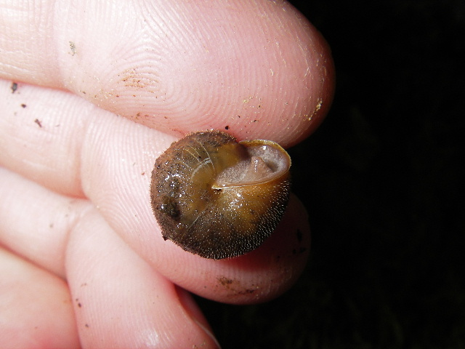
Vespericola species
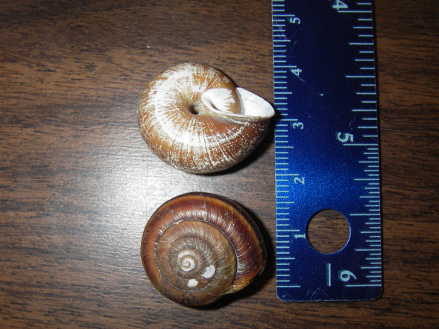 | 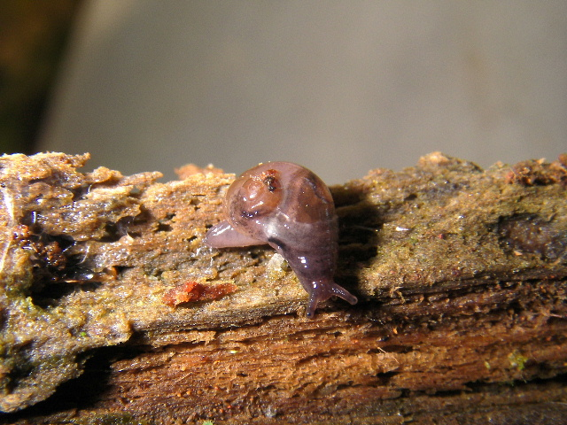
Monadenia species | Vitrina pellucida

